Section 01:
Commands:
- wget https://raw.githubusercontent.com/allisonhorst/palmerpenguins/main/inst/extdata/penguins.csv
- ls
- hadoop fs -copyFromLocal penguins.csv /user/maria_dev/datasets/penguins.csv

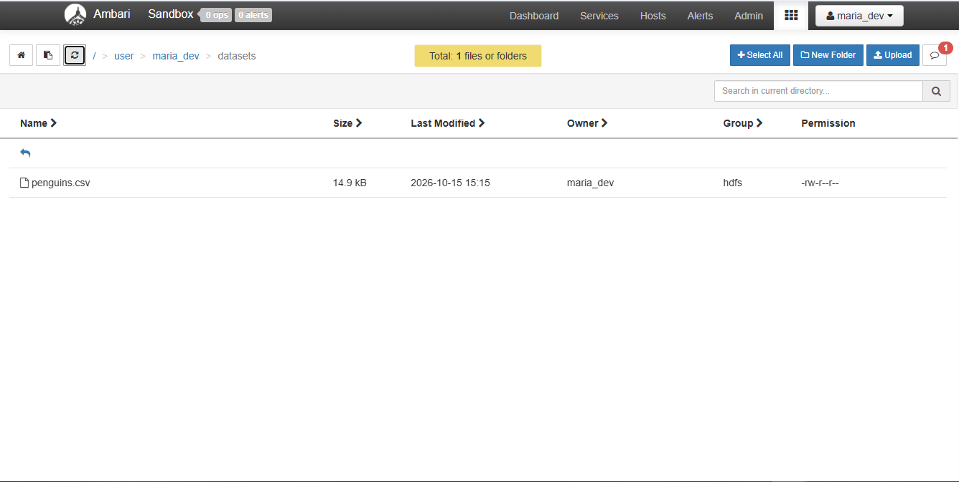
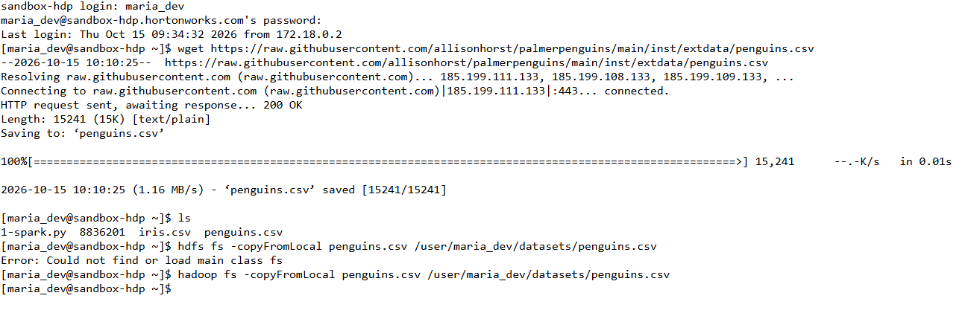
Output:
Section 2. Hive Table and HiveQL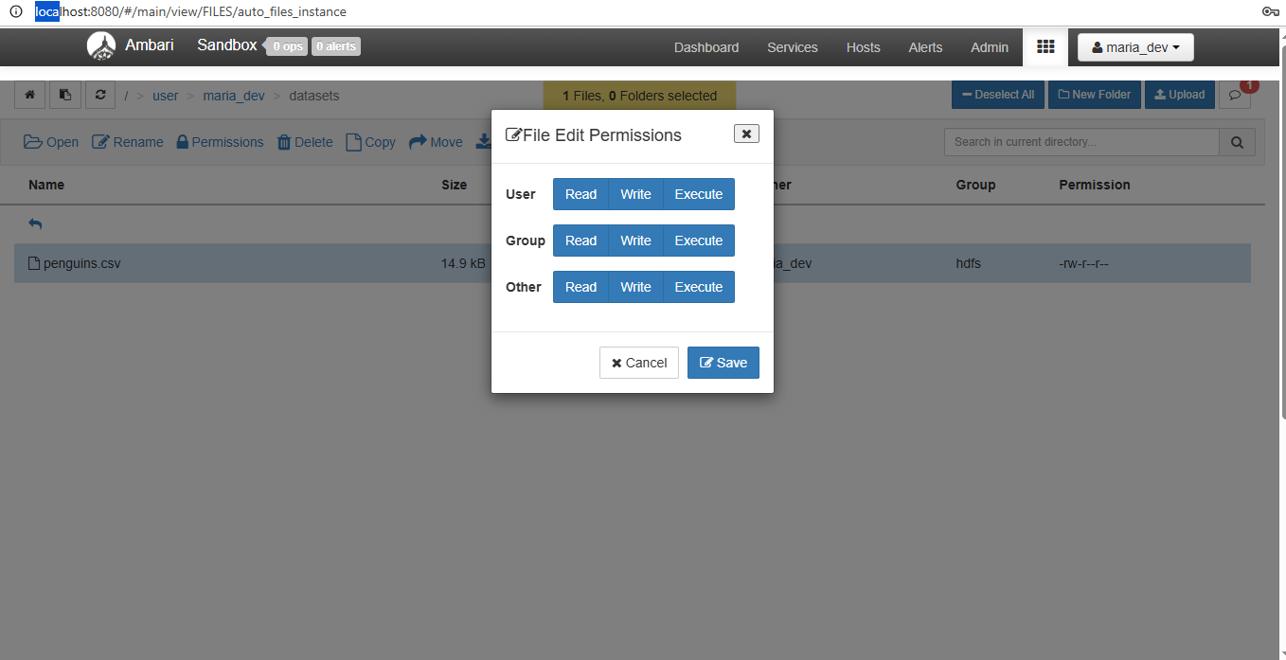
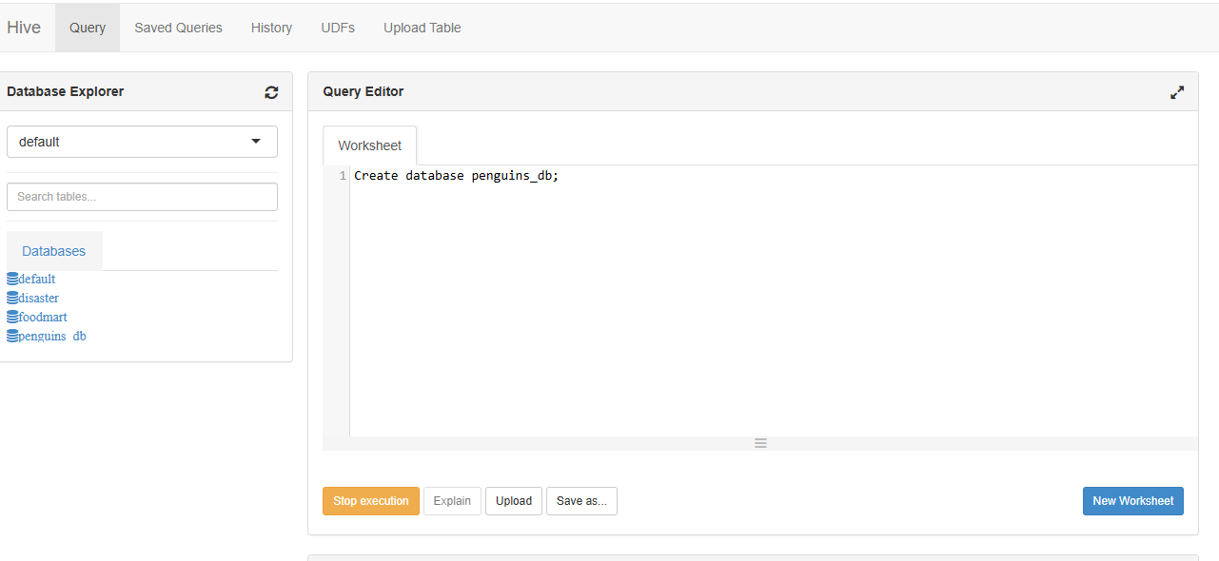
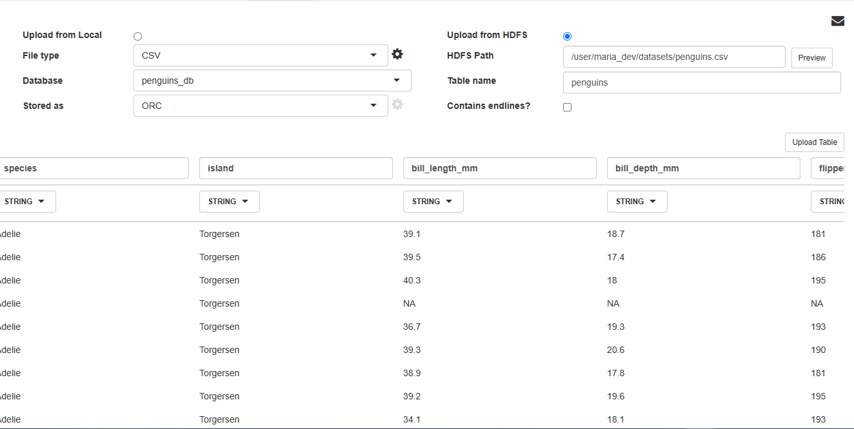
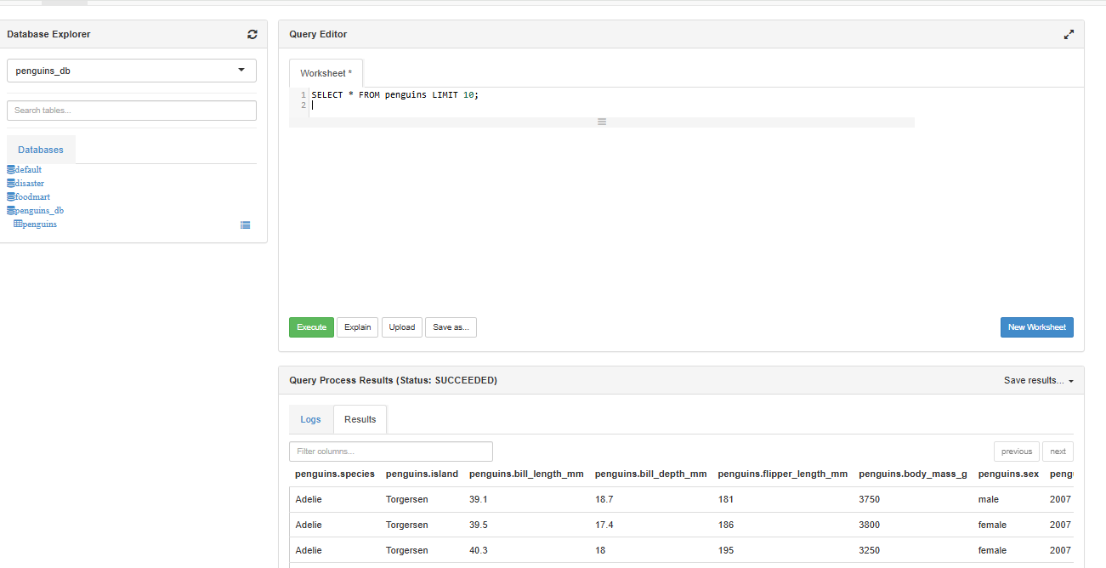
3a:
SELECT * from penguins;
3b:
SELECT species, island, COUNT(*) AS num_records
FROM penguins
GROUP BY species, island
ORDER BY species, island;

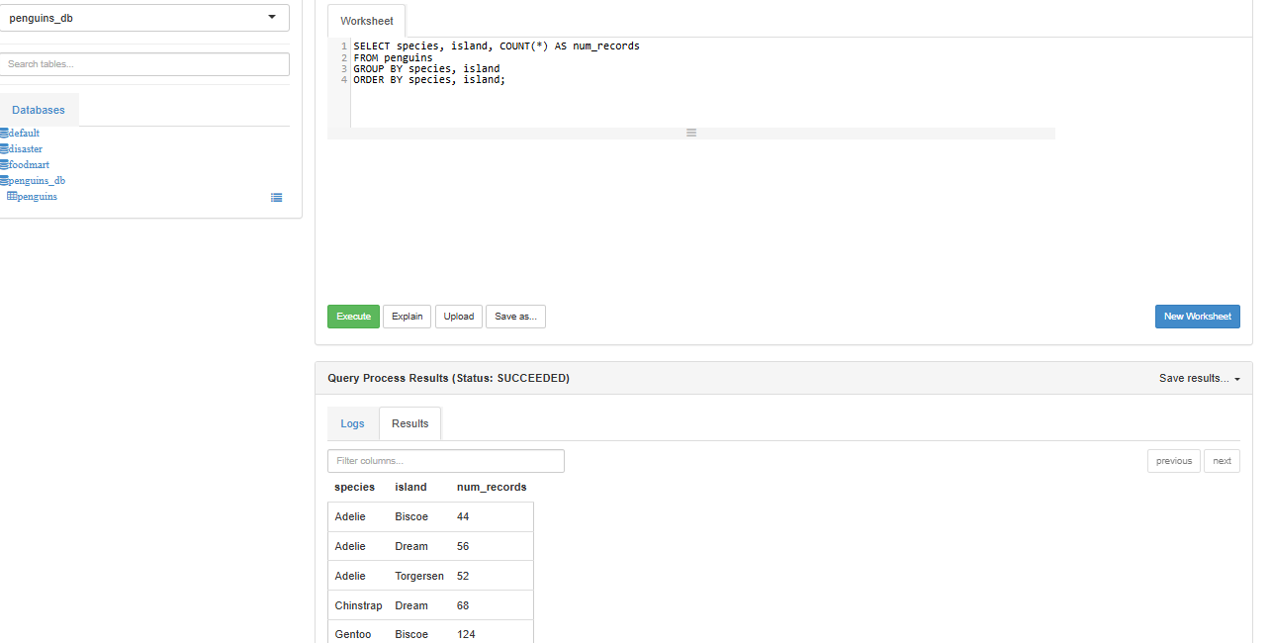
3c:
SELECT species,
ROUND(AVG(body_mass_g), 2) AS avg_body_mass_g,
ROUND(AVG(flipper_length_mm), 2) AS avg_flipper_length_mm
FROM penguins
GROUP BY species;

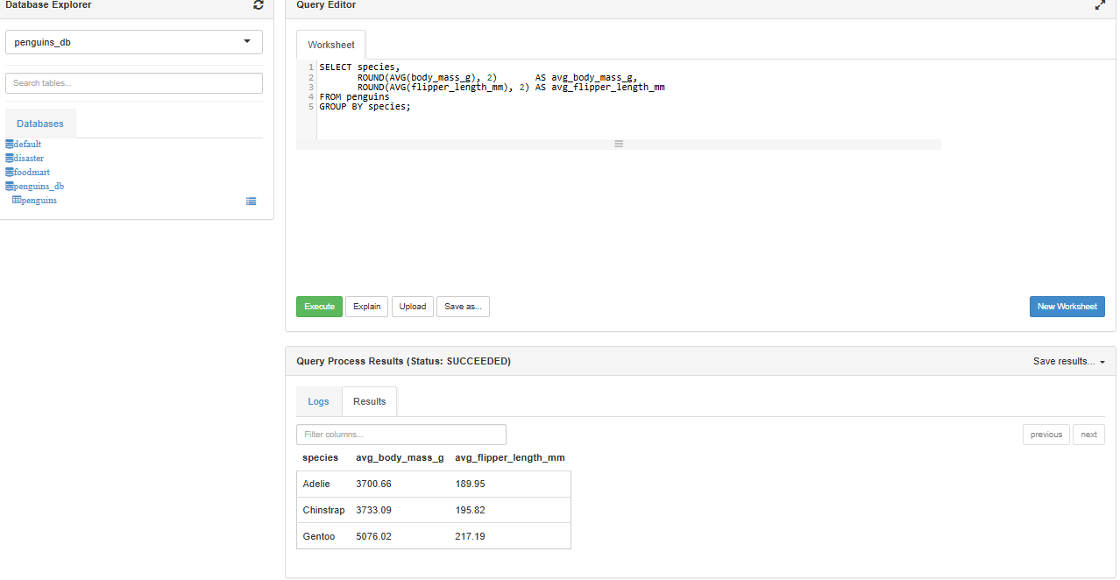
3d:
SELECT
SUM(CASE WHEN bill_length_mm IS NULL THEN 1 ELSE 0 END) AS missing_bill_length_mm,
SUM(CASE WHEN flipper_length_mm IS NULL THEN 1 ELSE 0 END) AS missing_flipper_length_mm,
SUM(CASE WHEN body_mass_g IS NULL THEN 1 ELSE 0 END) AS missing_body_mass_g,
SUM(CASE WHEN sex IS NULL OR sex = '' THEN 1 ELSE 0 END) AS missing_sex
FROM penguins;

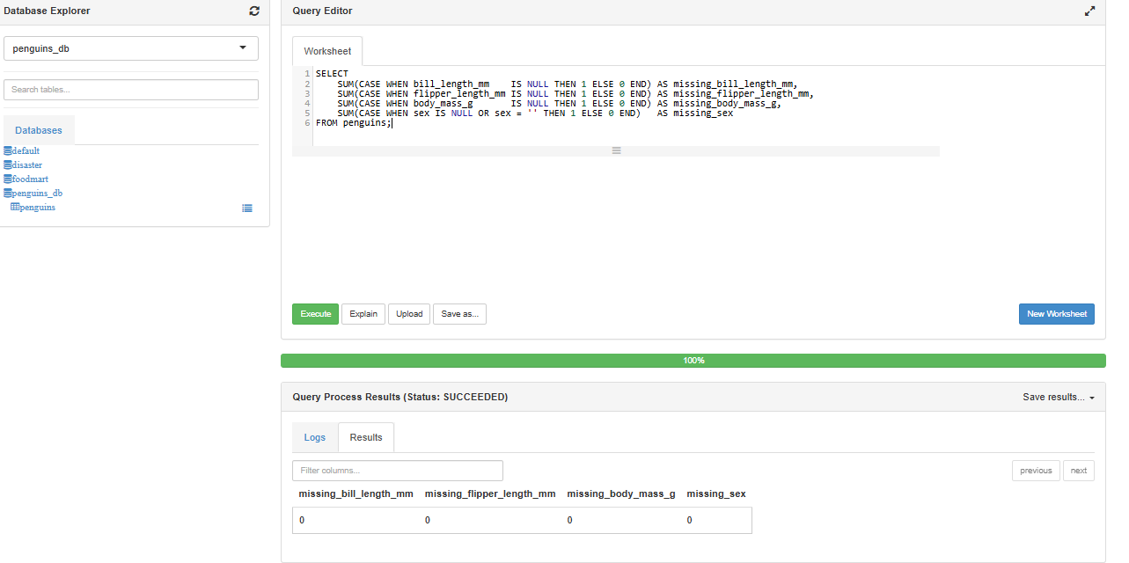
Section 3. ELT with WebHDFS InsecureClient
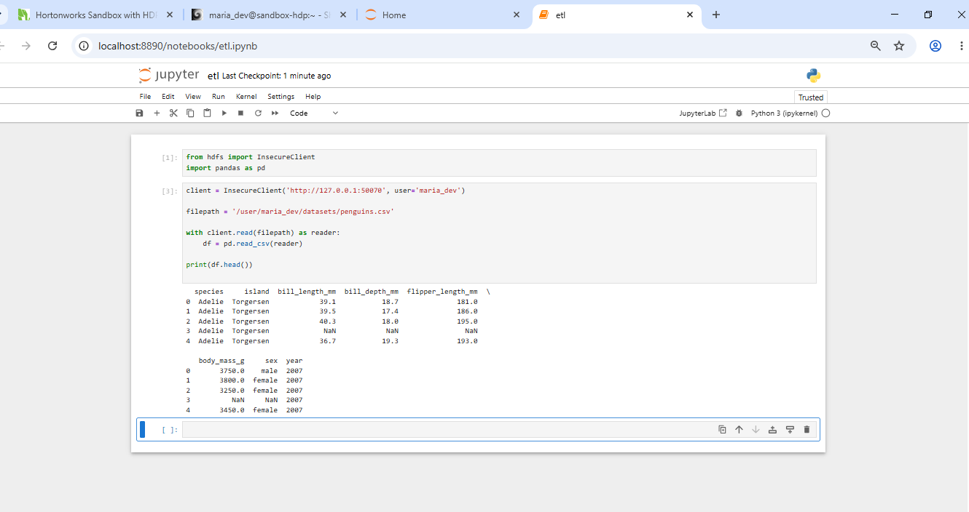
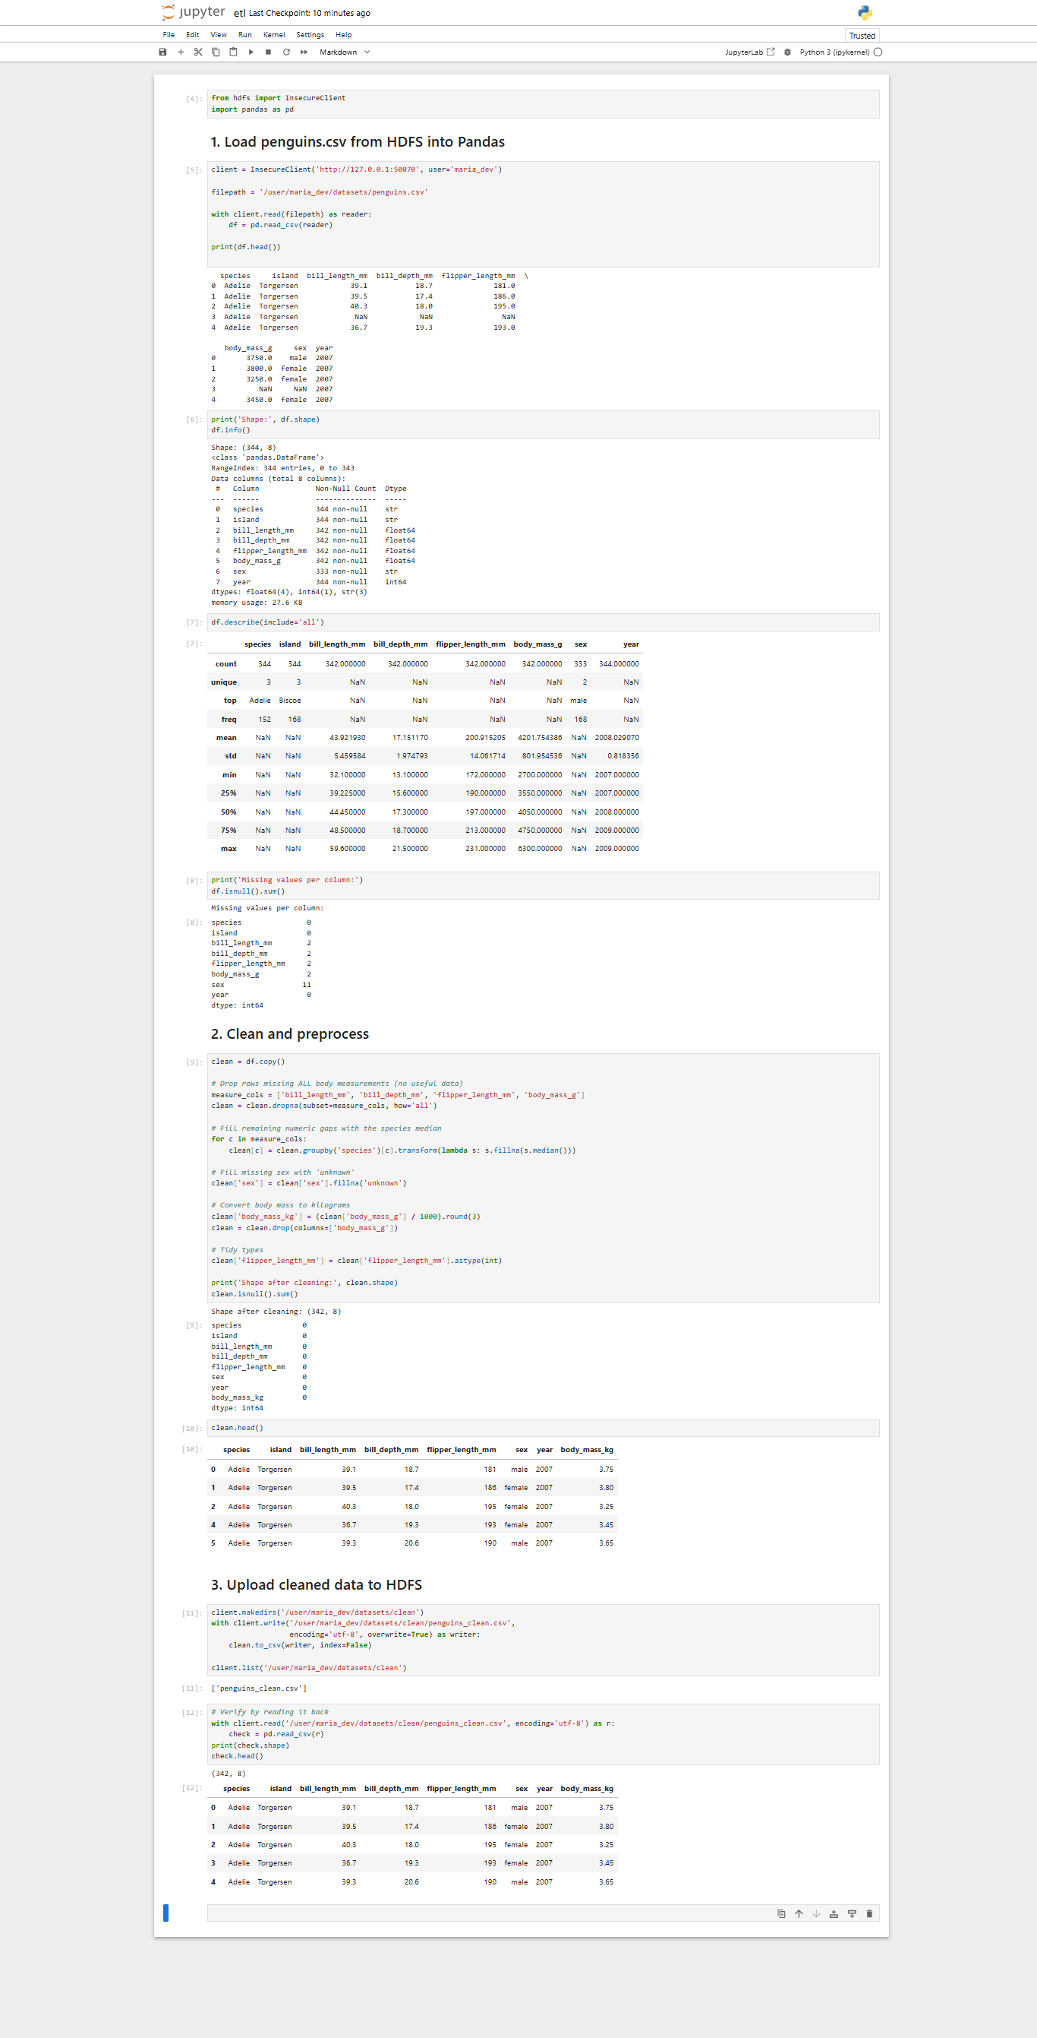
Output:
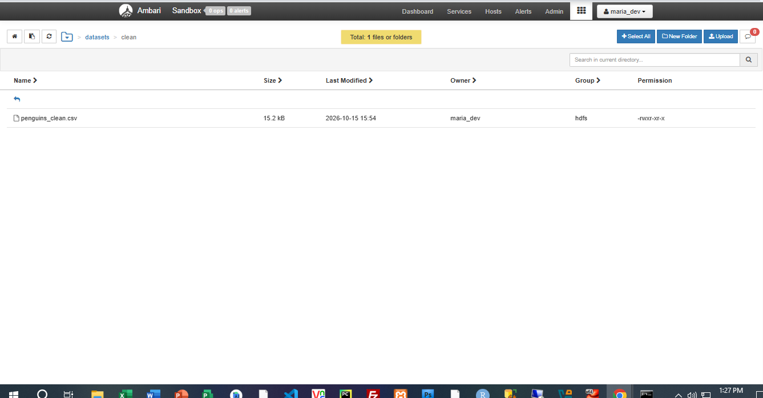

Section 4. PySpark Application on Hadoop
Commands:
- mkdir -p ~/spark

- hdfs dfs -get /user/maria_dev/spark/penguins_spark.py ~/spark/

- ls -l ~/spark/

- spark-submit --master yarn ~/spark/penguins_spark.py
